Blender project scizor 01/10/2026
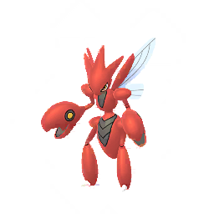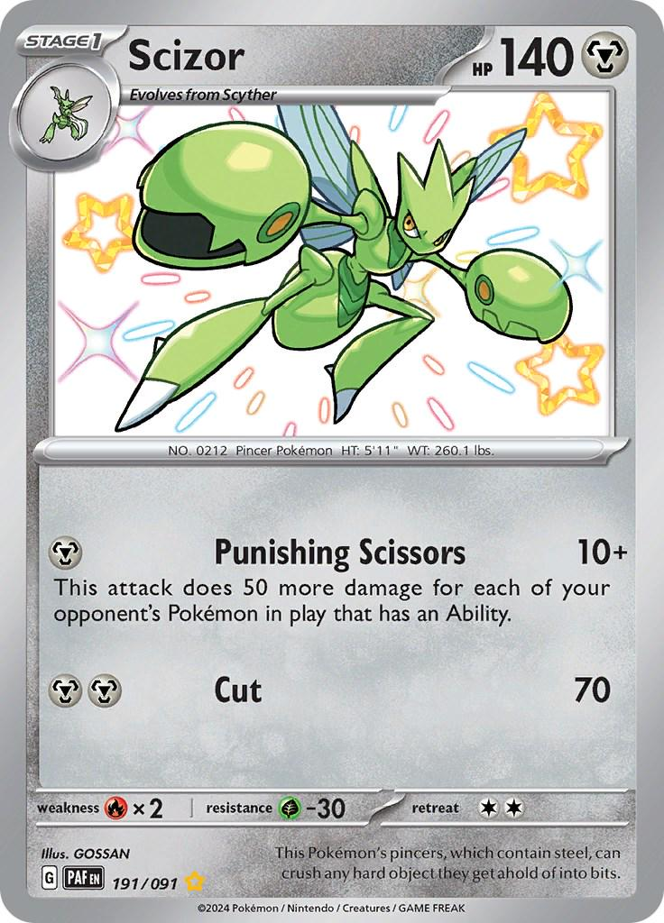

GOSSAN (2024) Scizor [Trading card]. Pokémon Trading Card Game, 191/091. The Pokémon Company / Nintendo / Creatures / GAME FREAK.

Day one just added the base body to be cleaned up later
